Part 1: Capturing HTTP Traffic
Task 2: Filter HTTP packets and analyse them
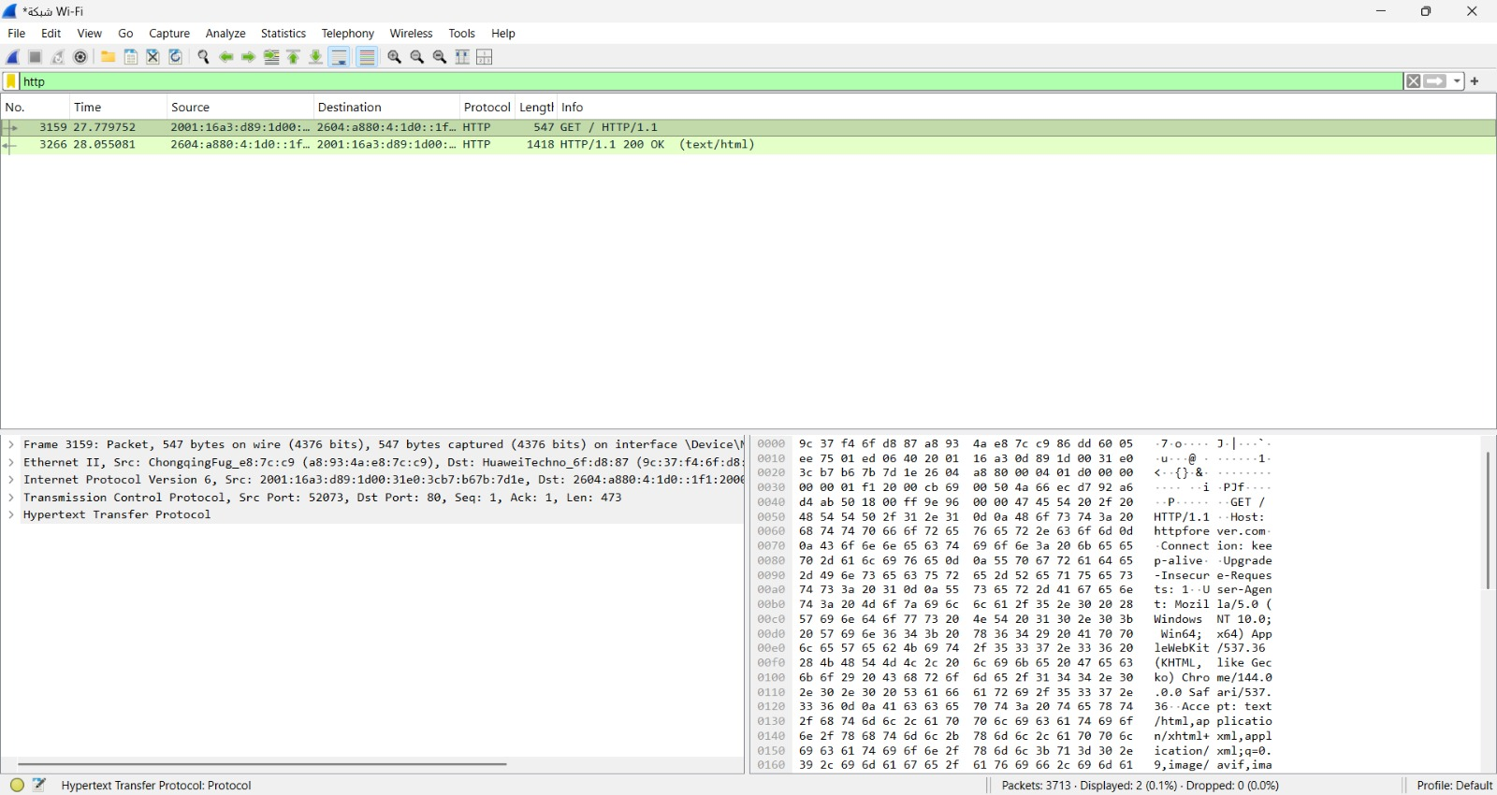
Part 2: Analyzing TCP/IP Traffic
Task 1: Filter TCP packets
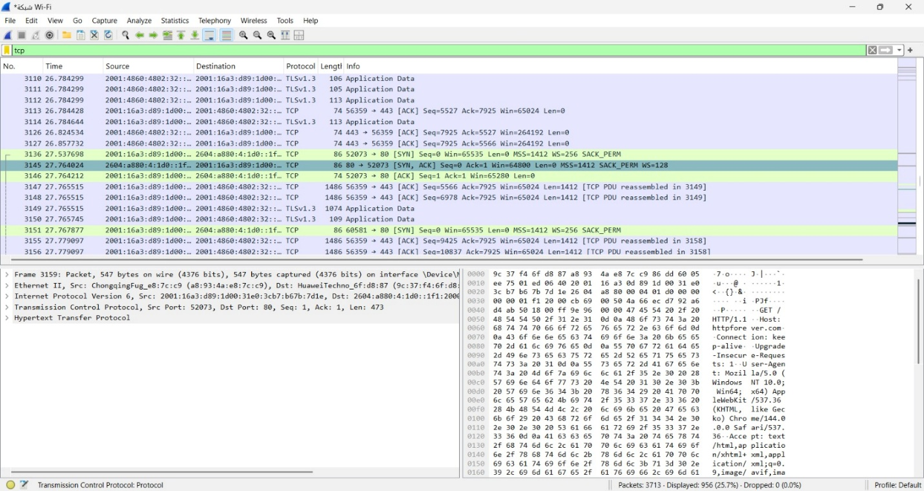

Task 2: Analyze TCP handshake and investigate Data Transfer and Termination
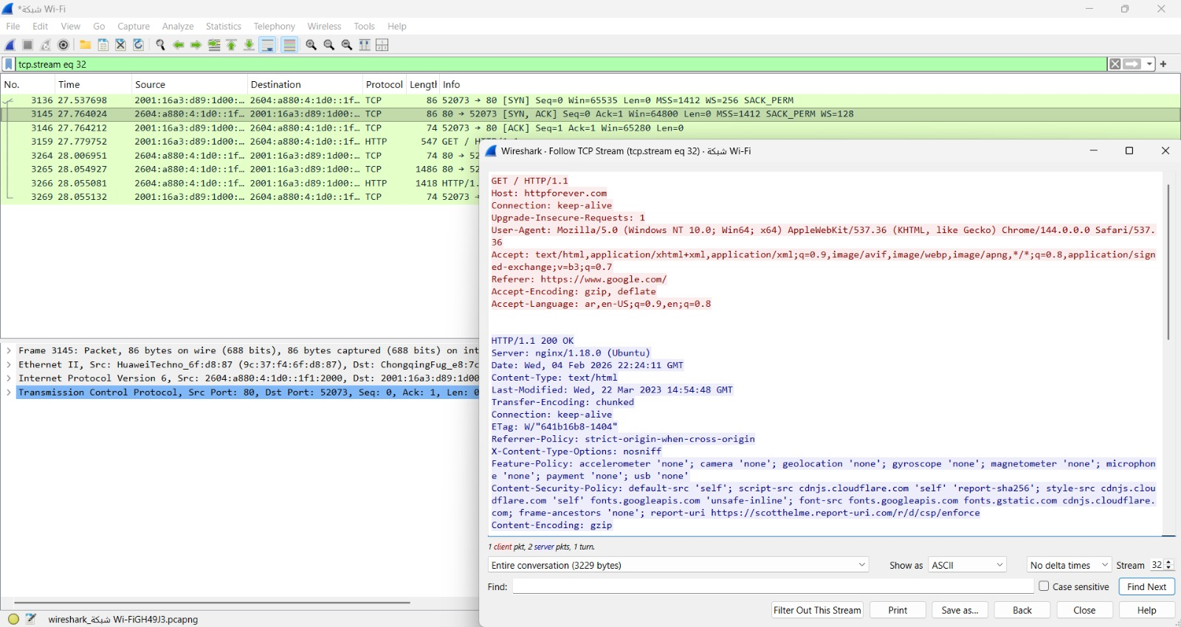

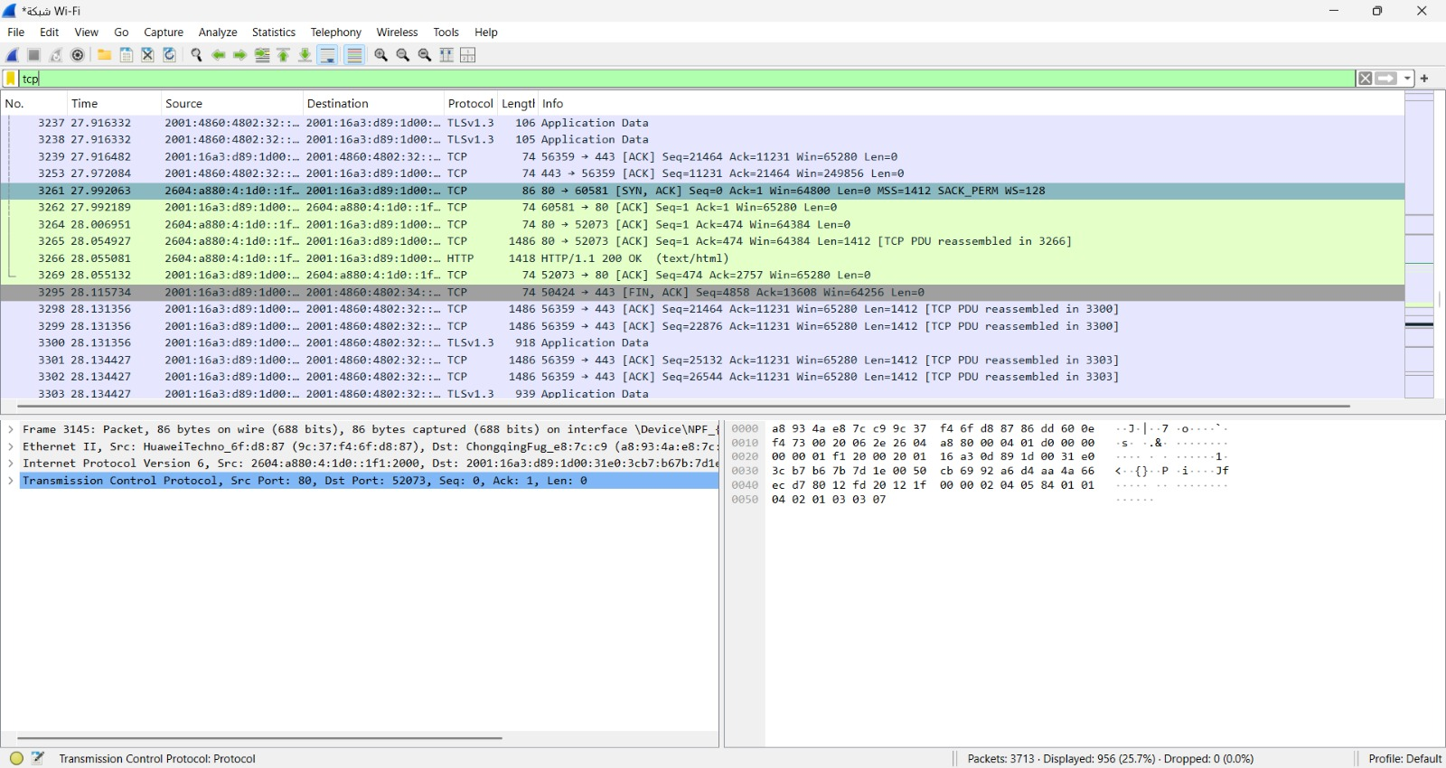

Part 3: Capturing and Analysing UDP Traffic
Task 2: Filter and analysis UDP Packets
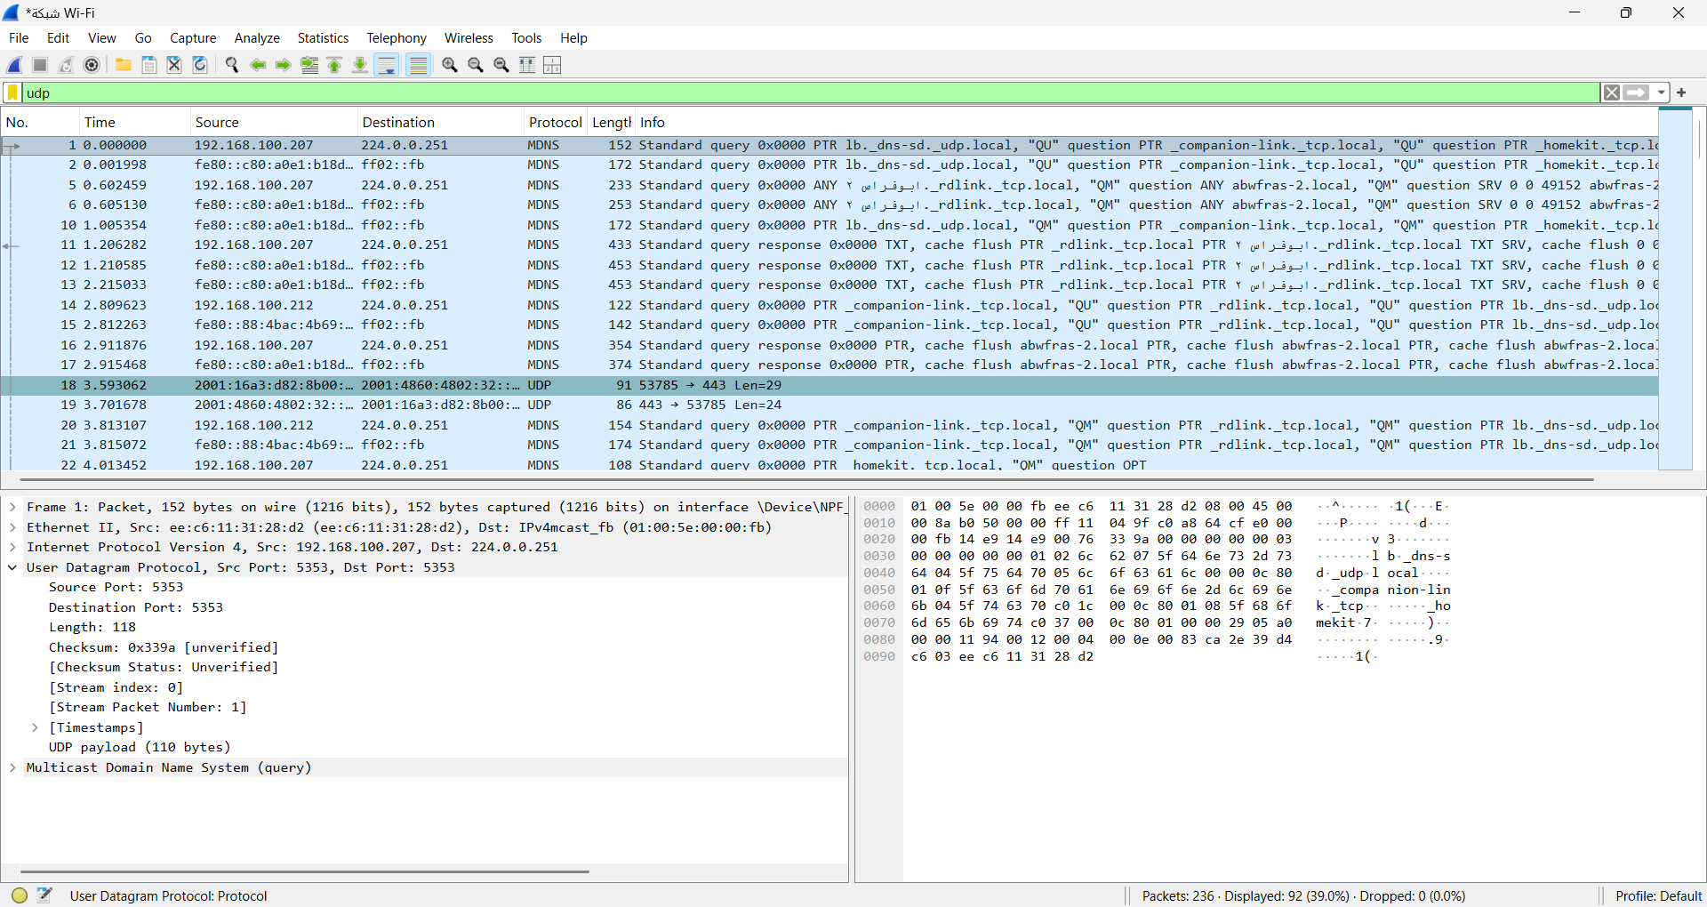
UDP has a simpler header than TCP. It contains fewer fields and does not support reliability or connection control, while TCP has a more complex header that supports reliable and ordered data transfer.
Part 4: Comparing TCP and UDP by filling in the following tables.

 | TCP or UDP | Reasons
Reliability and Connection Establishment | TCP | TCP is reliable and connection-oriented. It establishes a connection using a three-way handshake (SYN, SYN-ACK, ACK) before transmitting data.
Data Integrity and Ordering | TCP | TCP guarantees data integrity and ensures packets are delivered in order using sequence numbers and acknowledgments.

 | TCP | UDP
Use cases | Web browsing (HTTP/HTTPS), Email, File Transfer (FTP) | Video streaming, VoIP, Online gaming, DNS
Performance | Reliable but slower due to connection setup and error control | Faster with low latency, but no guarantee of delivery

